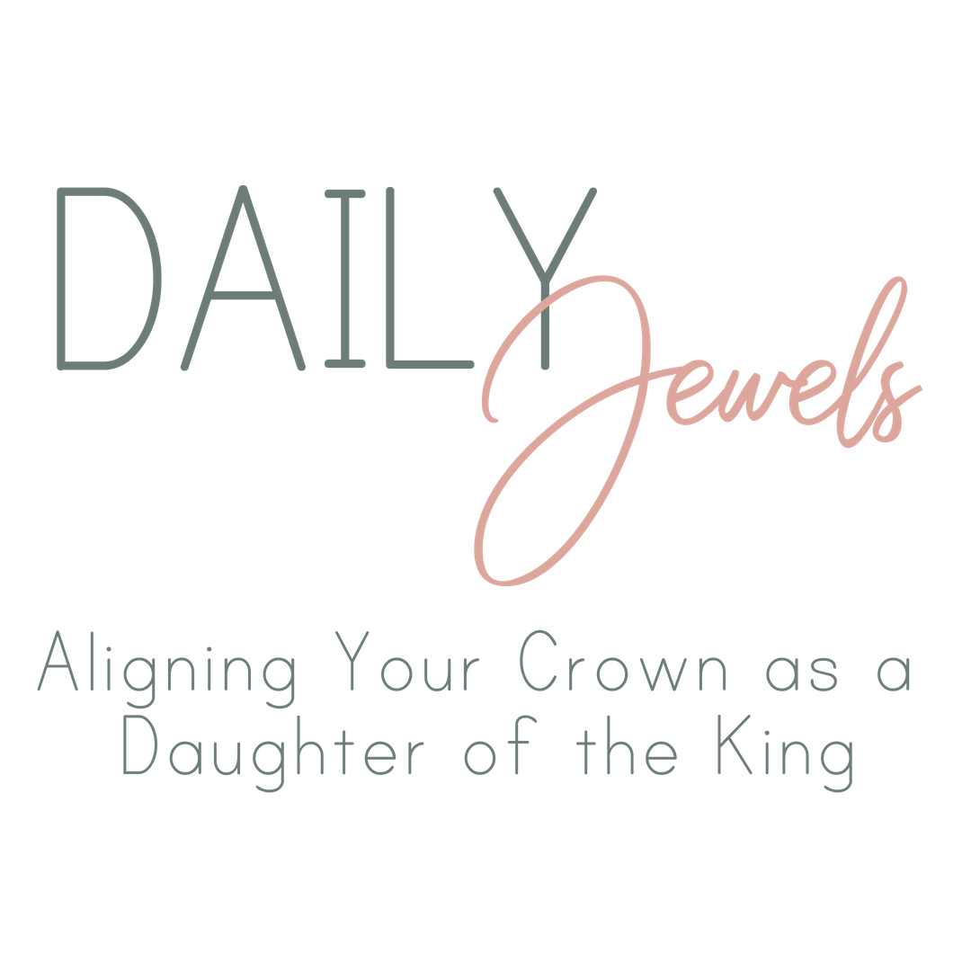

In the Bible, God has many names; Judge, King, Light, Redeemer, Shepherd, the I Am, and so many more. My favorite name He holds is FATHER! There is so much safety and security in knowing we have a Heavenly Father that rescued us from our sin and shame. He is alive today, just waiting for us to draw close. The next 30 days let’s go on a journey to discover HIS extraordinary jewels in the ordinary places of our lives. You are royalty, beloved, and a daughter to the King of Kings, the Savior of the World.

“Yet for us there is but one God, the Father, from whom all things came and for whom we live; and there is but one Lord, Jesus Christ, through whom all things came and through whom we live.” 1 Corinthians 8:6

Before you begin the devotion, I want to encourage you to take some time and look in the Bible or research online the different names of God in His Word. We need to be reminded that love, forgiveness, and grace has a name, Jesus Christ.

Each week this study guide will help you recap and dive deeper into God’s Word. I want to encourage you to use the blank spaces to write what is on your heart to your Heavenly Father. The next four weeks you will be able to trace God’s faithfulness in your life through His Word. In the midst of chaos, victory, defeat, loneliness, or exhaustion there is always a jewel to be found.

Week 1 Recap: Days 1-7

This week we were reminded of the white noise (distractions) in our lives, how important it is to rest in the Lord, and how He can make us brave. Use the space below to record what God revealed to you the last 7 days, and what daily jewels gave you hope (you can use the Daily Jewels index in the back of the book).

Week 1 Reflection: Days 1-7

This week reminds us of how God is our Creator God. Take some time and read John 1:1-3.

“In the beginning was the Word, and the Word was with God. He was in the beginning with God. All things were made through him, and without him was not any thing made that was made.”

How does it feel to know that the creator of the Universe also created you? When you grow weary, feel rejection, or need courage, run into the arms of your Savior. Below write a prayer to God with any struggles you may have right now. I pray you find comfort in the fact that God has already gone before you, and will never leave you. Ask the Lord to bring these daily jewels to your remembrance (John 14:26).

Week 2 Recap: Days 8-14

This week we read about diving deep with the Lord, never quitting, and how to depend on God in a “pruning season.” Use the space below to record what God revealed to you the last 7 days, and what daily jewels gave you hope (you can use the Daily Jewels index in the back of the book).

Week 2 Reflection: Days 8-14

This week reminds us of how God is our true vine. Take some time and read John 15:1-17.

“I am the true vine, and my Father is the vinedresser.”

Do you have any unbelief in your heart? Do you want to dive deeper in your walk with Jesus? The only way to do that is to read His Word and communicate with Him. Ask the Holy Spirit to reveal Himself to you in a new way. The Scriptures in John 15 tells us to abide in HIM. Look up the definition of Abide and write it below. Share your heart with your true vine. 1 John 2:6 says, “whoever says he abides in Him ought to walk in the same way in which He walked.” We have the best example to live by through our Savior, Jesus Christ.

Abide:

Week 3 Recap: Days 15-21

This week we learned how to hear God’s whisper, the importance of who we are allowing to speak into our lives, and trusting God when we are misunderstood. Use the space below to record what God revealed to you the last 7 days, and what daily jewels gave you hope (you can use the Daily Jewels index in the back of the book).

Week 3 Reflection: Days 15-21

This week reminds us of how God is our redeemer and our rock. How has God been a rock in your life?

“In You, O Lord, I have taken refuge; Let me never be ashamed; In Your righteousness deliver me. Incline Your ear to me, rescue me quickly; Be to me a rock of strength, A stronghold to save me. For You are my rock and my fortress; For Your name’s sake You will lead me and guide me.” Psalm 31:1-3

One way to live an eternal legacy is to depend on the “rock” for your strength. Dive into Psalm 31 and write about how God has redeemed (delivered) you through His Word and comfort. “Incline your ear…” and ask God to lead and guide you.

Week 4 Recap: Days 22-30

This week you may be facing an invisible battle, maybe you are craving joy, or you want the Lord to mend the broken pieces in your life. Use the space below to record what God revealed to you the last 7 days, and what daily jewel gave you hope (you can use the Daily Jewels index in the back of the book).

Week 4 Reflection: Days 22-30

This week reminds us of how God is our resurrection and life. He shines His light on the broken pieces and brings to LIFE something NEW.

“Jesus said, “I am the resurrection and the life. Whoever believes in me, though he die, yet shall he live.”
“He has made everything beautiful in its time. Also, He has put eternity into man’s heart, yet so that he cannot find out what God has done from the beginning to the end.” Ecclesiastes 3:11

We were not created for this world; we were created for our Heavenly Father. You are His daughter, and He is your jewel. You can find Him in every disappointment, question, hurt, fear, and loss. Write how God has spoken to you or moved in your life the last 30 days.

“Be on your guard; stand firm in the faith; be courageous; be strong.” 1 Corinthians 16:13

Don’t forget share your crown today!

